***Surveillance Rover***

*Sandeep Mourya1, Shantanu Nimbalkar2 , Anurag Goswami3,*

*Sunny Sall4*

*1*Department of Computer, St. John College of Engineering and Management, Palghar

In the constant effort to safeguard the country against enemy attacks and terrorists, defense forces need to be powerful than the enemy countries. To make defense more stronger there was need for the war machines like missiles and rockets, which could trace the enemies and their targets and destroy them to keep the country safe. Surveillance is a major thing which is going to secure anything as it is a tedious job peoples are getting boarded because of that it will might risky to observing all this things. Thus, a robot will be helpful which will continuously monitor thing. This robot continuously watch and send a live streaming of it to an authorized person. Because of that monitoring work will be some what easy and it will be more accurate because of technology. The implementation of this project is to reduce human efforts, which can also contribute to their safety concerns. Robots are usually miniscule in size which can help infiltrating or inspection through tunnels, sewers and small holes in building. Also, due to their size they can survive severe climatic conditions for longer time. This project is mainly designed for surveillance of ground in military applications. The project is presented in an advanced Robotic system which can be controlled through RF signals and the robot's geographical position can be continuously monitored. It has many wide applications such as, Surveillance for military purposes, naxal threatened area, restricted areas or unhabited places between international borders, hijacked buildings. It can also be used to study animals, security systems, safety monitoring in industries, monitoring of contagious patients who are kept isolated.

Keywords-Arduino, Sensors, Arduino IDE

**Introduction**

This project aims to design a robot which can produce a visual report of restrained places like any building under a hostage situation. The critical aspect of the robot is that it carries an onboard video camera. Surveillance is the scannig of behavior, actions, or information for the purpose of influencing, managing or directing. This can incorporate inspection from a distance by means of electronic equipment, such as closed-circuit television (CCTV)[1]. According to Tom Harris, robot is an electro-mechanical machine that is controlled by a computer program or electronic device. It is being used to give ease to human by doing particular task. Robots are able to execute the task that are impossible. From this advantage, it can give many advantages in term of safety, ease and efficiency [2]. Surveillance system and robots are two distinct systems that accomplish their own task respectively. The main influence for this project is to blend these two systems to develop a mobile robot equipped with a camera as an intelligent surveillance system. By using this surveillance robot, the image visualize can be more adequate compared to other regular surveillance system since its numerous observing angle can be varied. This robot can be used as a standard for a monitoring system wirelessly by remotely-controlled by human via computer [3]. Using a robot for surveillance purpose is better than the static cameras placed at fixed positions, the robot is capable of dynamically patrolling the building. It can move from room to room, using its sensors to scan for odd presence of any person or anything that can go unnoticed from static cameras, and using its actuators to interact with the environment in ways that a static camera cannot. The robot’s limitation, however, is that it can only occupy one physical location at a time. CCTVs also contributes to surveillance but it has some drawbacks like it’s static position. Drones can be detected using radar system. Household surveillance can also be done by using this project. This project can also helps in household surveillance. Traffic surveillance and activities can be monitored. It can be used in situation of hijacked areas/buildings.

**Background and Literature review**

*Similar Projects*

There are some projects avaialablee about the surveillance robot where a movable robot is rigged with a camera and the robot is used for exploring purpose not for only monitoring. The robot contains a massive and simple chassis to carry the electrical parts and the useful cargo.2 mm thick fine steel plate was use for Base. That contains the suspensions of wheels, the recessed holder of the accumulator and some sensor fixation point. Separated plates to make possible to use vibration damper equipment’s was use for the wheel suspension. It shows the robot is controlled by ATMEL ATmega128 microcontroller[4]. It’s a fully automated type of robot where it consists of sonar sensor for obstacle avoiding and infrared sensor for a wall following function. It used a wireless camera in order to transmit the image captured on-site to a monitoring station. The robot contains a massive and simple chassis to carry the electrical parts and the useful cargo. The base was made from 2 mm thick fine steel plate. That contains the suspensions of wheels, the recessed holder of the accumulator and some sensor fixation point. The wheel suspension has formed from separated plates to make possible to use vibration damper equipments[5]. The Figure 1 shows 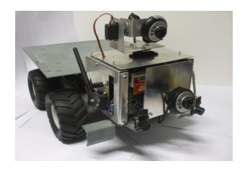the snapshot of the autonomous explorer mobile robot

**Fig 1: Autonomous explorer mobile robot[5]**

The robot can be controlled remotely, or can be assigned to go to a location, known by its inner map. In both cases, the user and the rover communicate through the local Wi-Fi network, using the same java programs. When the robot controlled manually, the user has to choose this function on the application window and then use the direction button on screen, or on the keyboard. In this mode, the signal processing is minimized to the level of collision detection. When the user just wants the robot to go to the chosen location, regardless of the path of the movement, it can be done by selecting an end location from the robot’s map. This map is the visualization of the graph that allows the construction to find the optimal rout by applying the A-star algorithm. This means that the robot has to stand in a known starting point, with a known orientation. The rover is not able to tell the difference, so when it has to stop; first it waits a few seconds for the obstacle to move away. If it does not happen it bypasses it.

Another idea of developing a robot which can be used for video surveillance & monitoring which can be controlled through a Graphical User Interface(GUI) interface.

The robot is specially designed for surveillance purpose. Initially, the robot is equipped with a camera or with an Android smart phone which will capture the scenario in front of it and will transfer the images to the server which provides control of the system and functionality to watch the live feed. The robot is controlled by wireless communication using Zig-bee module. Forward, right move, left move and backward direction from the Microcontroller is used to drive the robot in any desired direction. The main objective of this system is to get camouflaged including some additional parameters like blue-tooth module for real time data processed by the camera at the video screen and Passive Infrared Sensor(PIR) sensor to trace the intruders[6]. Thus the proposed system using blue-tooth reduces errors at defence and keeps the nation secure from the foe. A wireless camera is mounted on the robotic body. This wireless camera is used to monitor the exact position of the enemies and send it on real time base. The robotic motion is control by Radio Frequency (RF) technology. Wireless controlled military combat robot system is used to detect objects from a far place to the exact position in the battle field and necessary steps can be taken to attack the enemies. This system is also used with the help of visual display of the field so that it can be easy to control the robot and for positioning the weapon for shooting. With this system, lives of army soldiers can be saved, by planning well before attacking. This robot can provide the clear picture of battle field making battalion to move as per situation. This system is not sensitive to weather conditions. This robot does not need more supply to operate. It consumes 12v DC power supply and having wireless camera to observe the surrounding environment. The robot can be used in place which is hijacked by terrorists.

The robot is controlled by a RF (Radio Frequency) transmitter and receiver module. The receiver block consists of RF receiver, Decoder, driver unit, relay unit, sensor unit, buzzer for indication of toxic gas, motor units for movement of robot and water pump. A micro wireless camera is fitted on the robot where the video and voice are transmitted to the required place i.e. control room. The Figure 2 shows the System Architecture for Wireless Robot.

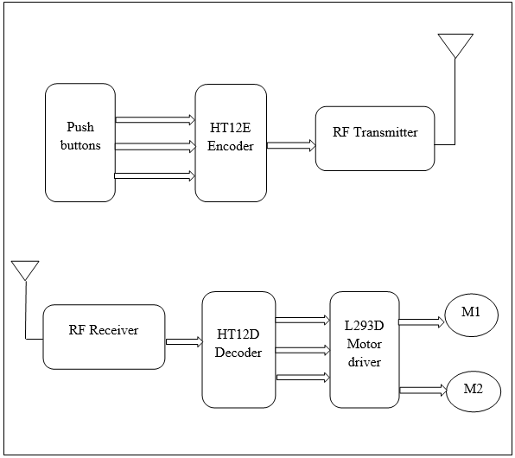

**Fig 2: System architecture of wireless robot**

**Proposed System**

*Block Diagram:*

The purpose of this project is ground surveillance in military applications. The essential devices that we have used on the robot are wireless camera, two pairs of RF transmitter-receiver, temperature sensor, Ultrasonic sensor & gas sensor The robotic actions can be controlled wirelessly by the user with the Joystick present on the user module via radio frequency. Along with the live streaming, the robot also senses the temperature of the robot's surrounding. All the four wheels are energized. Hence, the robot is able to rotate about 360 degree on stand. The project presented by us is an advanced Robotic system which can be controlled through RF signals and the robot's geographical position can be continuously monitored. The proposed prototype has a wide application such as, military ground surveillance in naxal threatened area, no man's land between international borders, hijacked buildings. It can also be used to study animals, Stand-alone security systems, Safety monitoring in industries, Continuous monitoring of epidemic patients who are kept isolated. The main surveillance rover will act as a receiver node in terms of the RF communication, which explores the area and captures images and streams live video of the surroundings. It also senses harmful gases present in the surrounding environment. The Figure 3 shows the architecture diagram for Surveillance Rover.

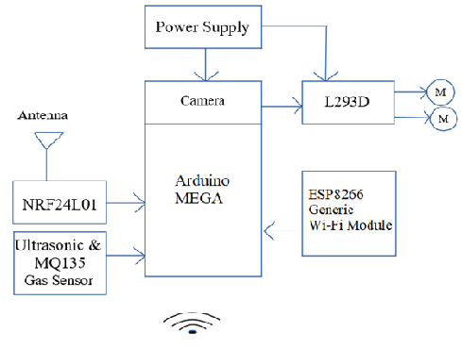

**Fig 3**: **Architecture Diagram for Surveillance Rover**

This architecture describes the interfacing of different components with each other and the Arduino MEGA Board. The power supply is given to Arduino and L293D Motor Driver. A Camera module is mounted on Arduino board. The L293D has two DC Motors connected to it which will be used to drive the rover. A wi-fi module ESP8266 is connected to Arduino which is used to provide wireless connection between different modules. NRF24L01 is a Radio Frequency Transceiver module which is also connected to Arduino. The other part of the system is a controller of the rover. It is a joystick module which establishes communication with the main surveillance rover using radio frequency. The joystick controls both X and Y axis directional controlling of the rover. The Figure 4 shows the Architecture diagram for Surveillance Rover controller.

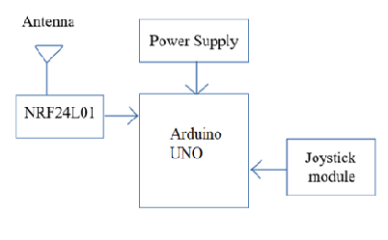

**Fig 4**: **Architecture Diagram for Surveillance Rover Controller**

This architecture diagram describes the interfacing of the controller part of the rover system. It’s main task is to only control the main rover system wirelessly. It has a Joystick module which is mounted on the arduino board. The joystick provides controlling at X and Y axis. The NRF24L01 Radio Frequency Transceiver is used to connect this module to the main rover module which establishes a radio frequency connection between the two devices. An Antenna is used in NRF24L01 Transceiver module to increase the range of transmission. Surveillance will explores the area and provides live streaming of its surrounding using a camera module which is mounted on top of the rover. The Figure 5 shows a snapshot of Surveillance Rover. The snapshot shows the implementation of the Surveillance Rover System. The rover is based on a 2-wheeler Chassis and has the main rover module with Camera mounted on it. The camera continuously streams the video of the surroundings of the rover. The rover moves with a decent speed to maintain stability of the system. This whole module is controlled remotely via the joystick which is on the another arduino at a distance. This whole communication is dependent upon the Radio Frequency provided by the NRF24L01 Transceiver. The video streaming connection is established by Wi-Fi connectivity.

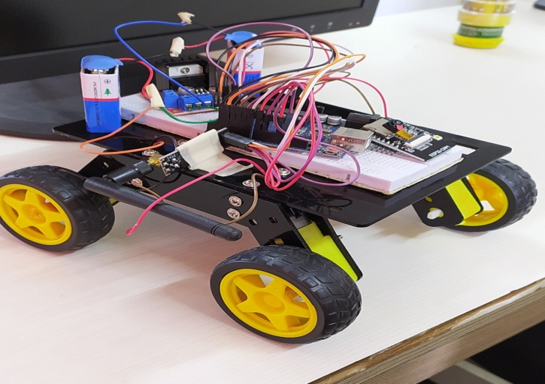

**Fig 5:** **Snapshot of surveillance rover**

The rover can move from room to room, controlled by transmitter device via RF sensors, and using its other sensors to interact with the environment in ways that a static camera cannot. The robot’s drawback is that it can only occupy one physical location at a time. The most important use of this project will be for surveillance. It can be used to infiltrate at various locations where it would be tough for a human to infiltrate without getting noticed. The project will be equipped with MQ135 gas sensor. The MQ-135 gas sensor senses the gases like ammonia nitrogen, oxygen, alcohols, aromatic compounds, sulfide and smoke.

To program the different components to function and establish communication with other components Arduino IDE is used. It is an Integrated Development Environment based on C, Java and developed by Arduino software.

To interface different components and module with each other coding is required to successfully establish a connection between them. The Figure 6 shows a screenshot from Arduino IDE software.

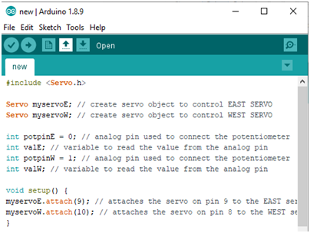

**Fig 6: Screenshot of Arduino IDE Software**

There are several header files already available to ease the programming for the smaller inner workings of the components but some modules require lines of code to work. The Arduino IDE is entirely used for programming of the Arduino board and different components. Once the programming is done, uploading the program to the board is required which is done by connecting the arduino to PC via a USB cable.

**Conclusion**

Thus, we have implemented Surveillance Rover which is mainly designed for surveillance of ground in military applications. The project is presented in an advanced Robotic system which can be controlled through RF signals and the robot's geographical position can be continuously monitored as well as it can detect the toxic gas present in the environment.

**References**

1. Dhanalakshmi.V, Jayasri.D, vishnupriya.R, “Zigbee Based Wireless Intelligent Security Robot For Defence Camp”, ISSN No: 2309-4893 International Journal of Advanced Engineering and Global Technology Vol-2, Issue-4, April 2014, pp.576-583
2. Harris, Tom (2002-04-16). <https://science.howstuffworks.com/robot.htm>
3. Prajakta Sathe, Neha Poojary, Archana Shitole, S.V.Bhise, “Advanced Surveillance Robot”, International Journal for Research in Applied Science & Engineering Technology (IJRASET), Volume 3 Issue IV, April 2015.
4. M. Kam, X. Zhu, P. Kalata, Sensor Fusion for Mobile Robot Navigation. Proceedings of the IEEE Vol. 85, Issue 1, pp. 108-119 (1997).
5. Csongor Márk Horváth and Róbert Tamás Fekete, “Development of Autonomous Explorer Mobile Robot for a Specified Environment” PhD Budapest University of Technology and Economics/Department of Mechatronics, Optics and Engineering Informatics, Budapest, Hungary.